**IG Tool** **User Guide**

Measure and manage your carbon emission

* Festivals and Outdoors Events
* Venues
* Offices
* Tours
* Productions



Produced in Partnership with:

**Contents**

1. Introduction 4

1.1 What is the LPA IG Tool? 4

1.2 What does an IG Tool measure? 4

1.3 Why use the IG Tool? 5

2 User Journey 6

2.1 Register 6

2.1.1 Terminology 7

2.2 Activities Tab 7

2.3 Account Tab 9

2.4 Add new Activity 11

2.5 Pick the Tool and create 12

2.6 General tab 13

2.7 Save and update button 15

2.8 Complete the rest of the Tool 16

2.9 Results tab 16

2.10 Deleting IG Tool Activities or Entries 18

2.11 Using the IG Tool as a database 19

3 Certifications and Awards 20

3.1 For Buildings 20

3.2 For Festivals and Outdoor Events 21

3.3 Other Relevant Tools 22

4 FAQs 23

4.1 Which IG Tool should I use? 23

4.2 Should I group activities per Season? 24

4.3 Can multiple users access the one Account? 24

4.4 I can’t access the LPA IG Tool 24

4.5 Can I reset my password? 24

4.6 What do I do if my building has been completely or partially shut for part of the reporting timeline? 25

4.7 My building has been completely or partially shut for part of the season? 25

4.8 How do I calculate my full-time equivalent employees? 25

4.9 How do I use the Tool if I am in shared office space? 26

4.10 How do I use the IG Tool if I am based in a University or local council? 26

4.11 How can I measure a city-based festival (e.g. the Adelaide Fringe)? 26

4.12 How do I proceed if I am a complex organisation with multiple spaces and events? 26

4.13 How can I measure an office-based organisation, which organises outdoor and indoor events including site specific work elsewhere? 27

4.14 Do the IG Tool allow me to offset my emissions? 27

4.15 Calculating the impact of accommodation on tour. 28

4.16 . Compare the reduced impact of a sub-tour. 28

4.17 If I still have questions about how to use the IG Tool what do I do? 28

4.18 How do I track success? 28

4.19 Where can I find more information on payback options for different capital investments I am considering? 29

4.20 What Grants or Financial incentives might I be entitled to in order to fund low-carbon solutions? 30

4.21 Having trouble reading my invoices to complete the IG Tool – what do I do? 30

5 Methodology and Definitions 33

5.1 How do the IG Tool calculate greenhouse gas emissions from your data? 33

5.2 How is the IG Tool data used? 33

5.3 Definitions 33

# 

# Introduction

By measuring your environmental impacts you will:

* Understand your environmental impacts;
* Identify carbon hotspots;
* Improve your brand value;
* Build stronger relationships with artists, staff, suppliers, funders, audiences and consumers;
* Prepare for compliance such as carbon reporting; and
* Save money by identifying inefficiencies in energy and resource use.

## What is the LPA IG Tool?

The IG (Industry Green) Tool is free online carbon calculators, which provide an instant read-out of the carbon emissions, generated by your creative organisation or activity.

They have been licensed from the Julie’s Bicycle in the UK and updated with Australian Greenhouse Gas (GHG) emissions factors, for the expressed purpose of the LPA Greener Live Performances project.

IG Tool is available for:

* Offices;
* Venues (theatre, music, galleries, studios);
* Tours (theatre, performing arts, music);
* Festivals and outdoor/temporary events (urban, greenfield); and
* Production.

To skip the introduction and go to the IG Tool directly click on: http://www.lpa.ig-Tool.com/signup

## What does an IG Tool measure?

The Office, Venue, Tour and Festivals and Outdoor Events IG Tool measure greenhouse gas emissions (GHG’s also commonly referred to as carbon emissions) produced by:

* Energy use;
* Water use;
* Waste generation;
* Business travel; and
* Audience travel.

The Production Tool measures greenhouse gas emissions produced by:

* Set design and management (embodied carbon of materials such as timber and steel);
* Lighting, sound and effects (energy use).

**Here is what each IG Tool tab measures:**

|  |  |  |  |  |  |  |  |  |  |  |
| --- | --- | --- | --- | --- | --- | --- | --- | --- | --- | --- |
| **IG Tool** | Energy | Water | Waste | Business Travel | Audience Travel | Freight | Artist & Crew Travel | Accomm | Set Design & Mgt | Lighting Sound Effects |
| **Office** | ✓ | ✓ | ✓ | ✓ |  |  |  |  |  |  |
| **Venue** | ✓ | ✓ | ✓ | ✓ | ✓ |  |  |  |  |  |
| **Tour** | ✓ |  |  |  |  | ✓ | ✓ | ✓ |  |  |
| **Festivals Outdoor Events** | ✓ | ✓ | ✓ |  | ✓ |  |  |  |  |  |
| **Production** |  |  |  |  |  |  |  |  | ✓ | ✓ |

## Why use the IG Tool?

The IG Tool was developed with festivals, venues, offices, tours and production companies to ensure that the environmental profiles of creative organisations and activities are fully accounted for.

**What makes the IG Tool unique?**

* Every entry contributes to the development of industry benchmarks and intelligence on how the sector overall is reducing its environmental impacts; and
* You are joining a community of cultural organisations pooling their data through Live Performance Australia’s Tool.

These Tool interpret your results through the lens of relevant, sector specific metrics e.g. on a per performance seat, a per audience day basis, a per $1000 of budget basis, etc.

This suite of Tool is designed to reflect the creative industries specifically and as such it measures audience travel and show power demand. Their design is informed by our research so that we can focus on measuring and changing the things that will make the greatest difference.

# User Journey

## Register

Register on the IG Tool website to access the Tool – it is free!

[***https://lpa.ig-Tool.com/signup***](https://lpa.ig-tools.com/signup)

PLEASE NOTE: If you have a disability that might prevent you from using the LPA IG Tool please get in touch. You can email us at [greener@liveperformance.com.au](mailto:greener@liveperformance.com.au) or call us at (03) 9614 1111.

CHECK

* **✓**= Remember to tick the box detailing our privacy policy.

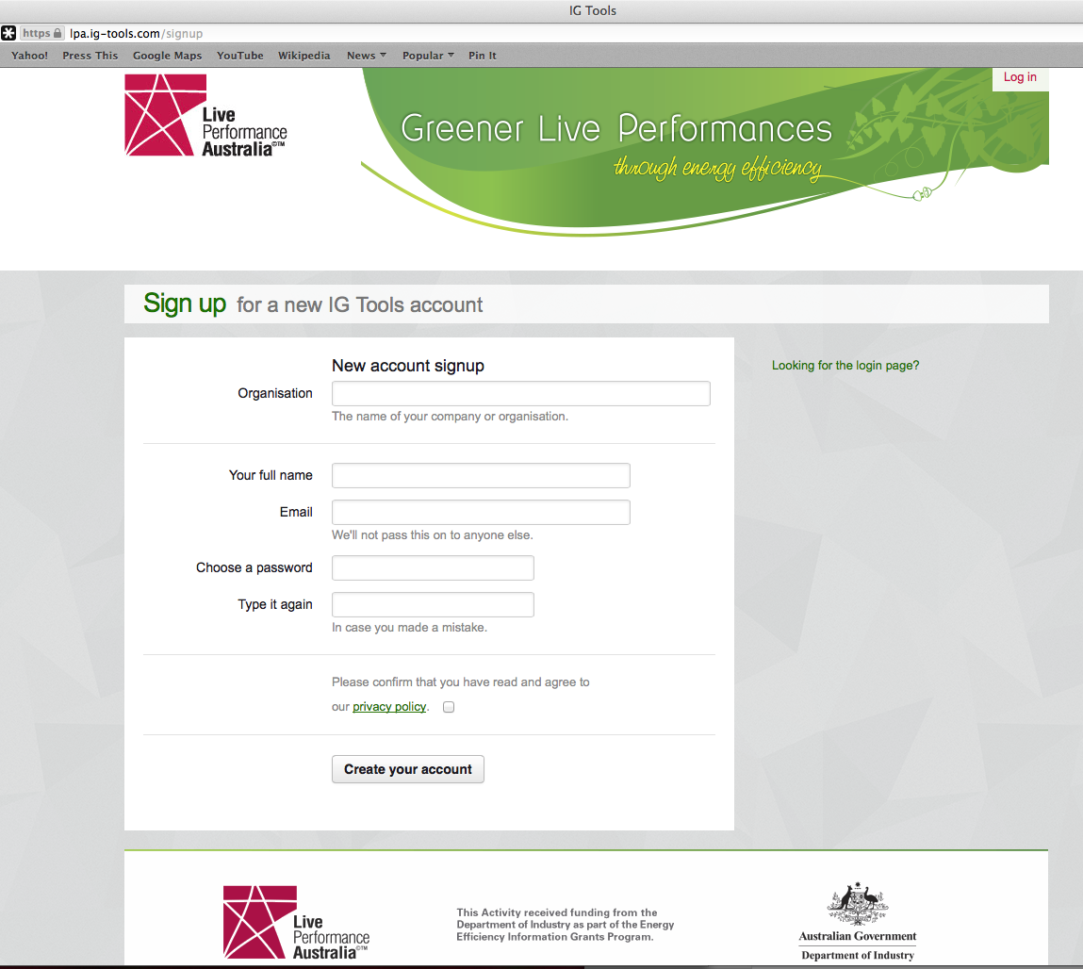

### Terminology

**Account** refers to your overall workspace in the IG Tool, for which you have an email and password to log into.

**Activities** refer to the specific activities you’ll be accounting for on the Tool. For example this might be your office space, venue, or outdoor event.

**Entries** are individual data entries created under each **Activity**. For example, an organisation that represents several festivals creates an **account** under its name, “Festival Management.” It then creates an **Activity** for each of the festivals it represents e.g. “Funland,” “Chaos” and “Solstice Fest.” For each of those festival **Activities**, individual **entries** will be created, e.g. “Funland Emissions 2012-2013”.

## Activities Tab

Once you log in to the IG Tool you will be automatically taken to your Activities tab (a page that summarises all the IG Tool entries you have ever created across all IG Tool).

On the left hand side you can sort your existing IG Tool entries by Activities, by clicking on the type of activity you would like to view (i.e. Outdoor Events, Offices, Venues/Cultural Buildings, Tours or Productions).

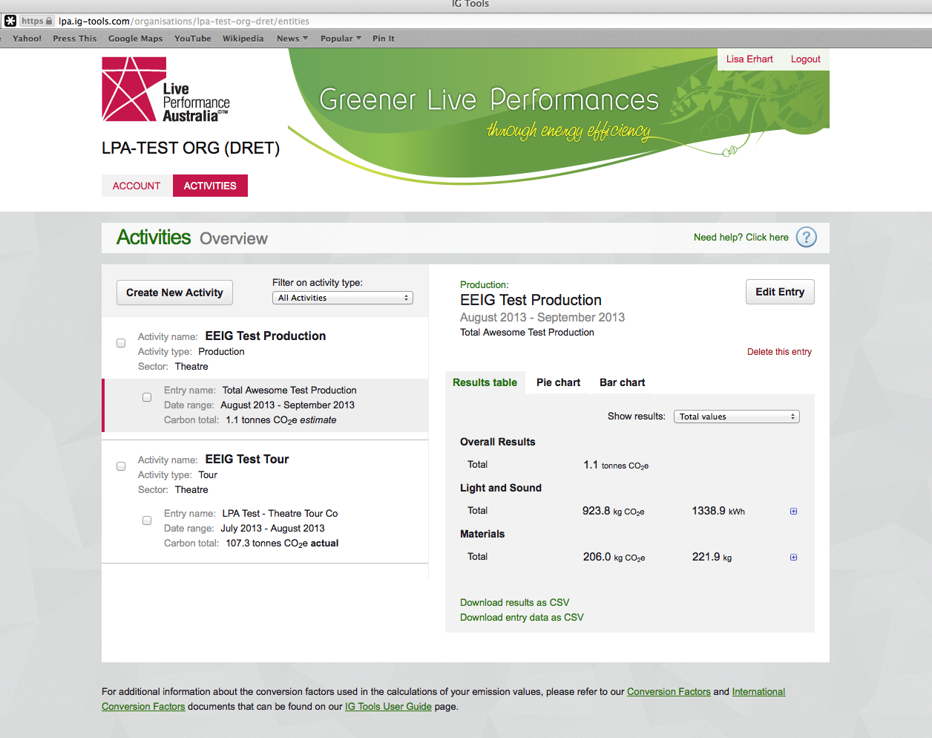

You can also edit any of your existing entries by selecting the entry you want to edit from the middle column (selected entry will be highlighted in light grey).

At any point you can opt to log out of the IG Tool by clicking on Logout on the top right hand side corner.

**CHECK**

* All Tools ask you to **check a box if the data you are entering is actual** (i.e. to assess you carbon impact post-event, post-production, post-tour, etc.). If you do not check the box we assume all data entered is planning data (i.e. estimates), allowing you to use the Tool for planning purposes as well.   
    
  For example you might like to know how much more carbon intensive air freighting is as opposed to sea freighting when you are planning your tour.
* You can quickly see which of your entries are actual vs. estimates on the Activities tab (appearing as ‘actual’ or ‘estimate’ after the kg CO2e number).



## Account Tab

Once on the **Account** tab, you can view the details of your IG Tool account, and edit those details, ensure you save any changes that are made before leaving the account section.

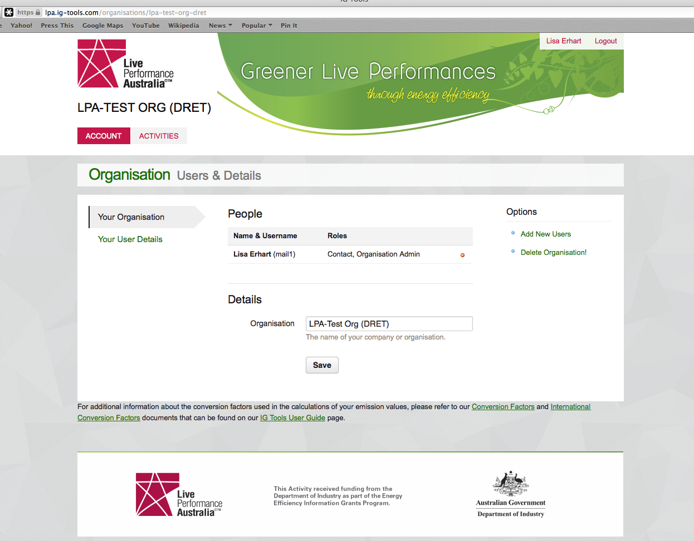

You can also invite colleagues to the account by clicking on **Add new users.**

Enter the email addresses of the colleagues you wish to share your IG Tool entries with. Individuals added can either be assigned as the account **administrator** in which case they will be able to view and/or edit all Activities/ Entries, or they can be assigned as **manager** of an Activity (or entries), in which case they will be able to view and/or edit just that Activity/Entries (but will still be able to view yet not edit all other Activities in the account).

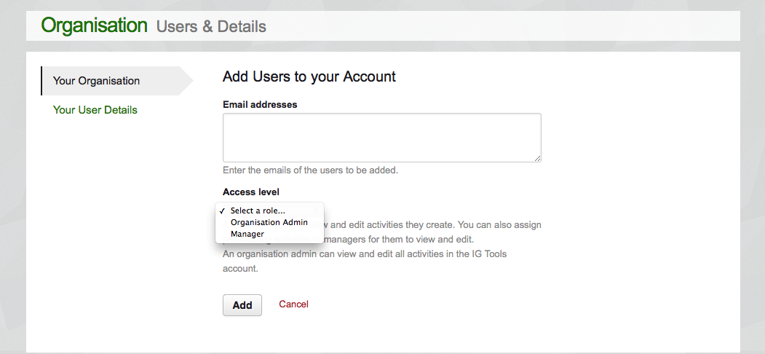

You can also assign specific Activities to individuals.

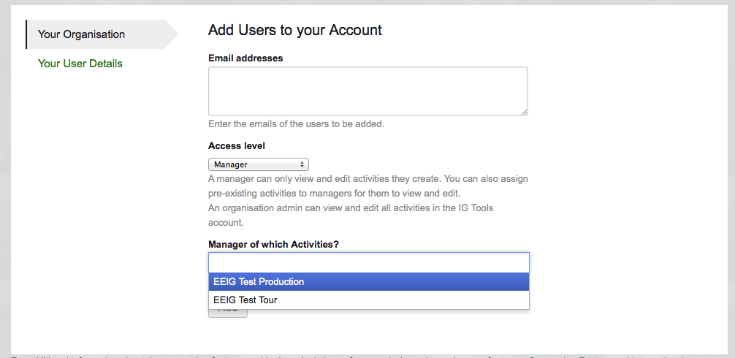

When you have added all the colleagues you wish to invite, click on ‘Add’.

By clicking on Your User Details on the left hand side (indicated by Your User Details being highlighted in light grey), you can also view and edit the details of your Account, including your password (for more details on how to reset your password see FAQs).

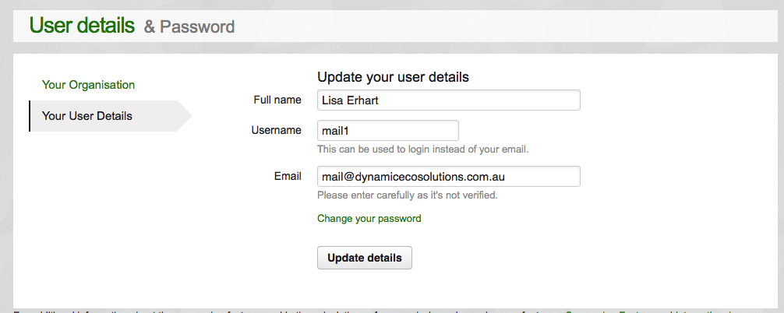

## Add new Activity

To add a new Activity click on the Activities tab, and then on Create New Activity on the bottom left hand-side of the screen.

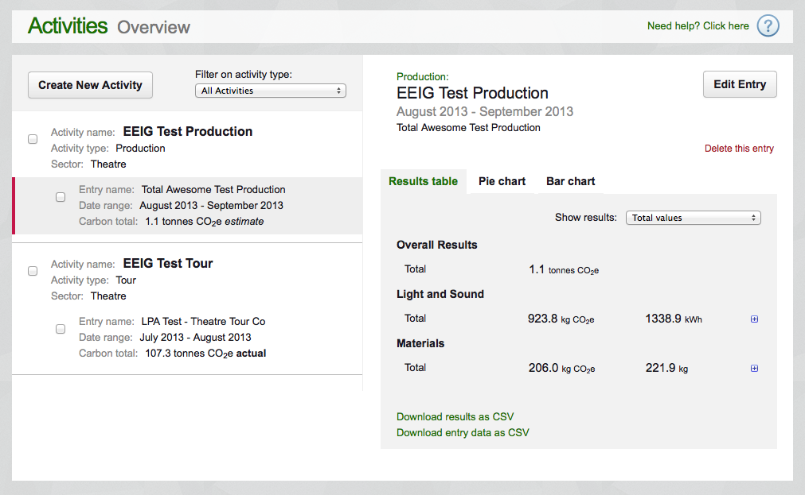

## Pick the Tool and create

Pick the IG Tool you want to use (i.e. Outdoor Event, Office or Venue/Cultural Building), insert a name for the Activity you will be creating, and click on Create New Activity.

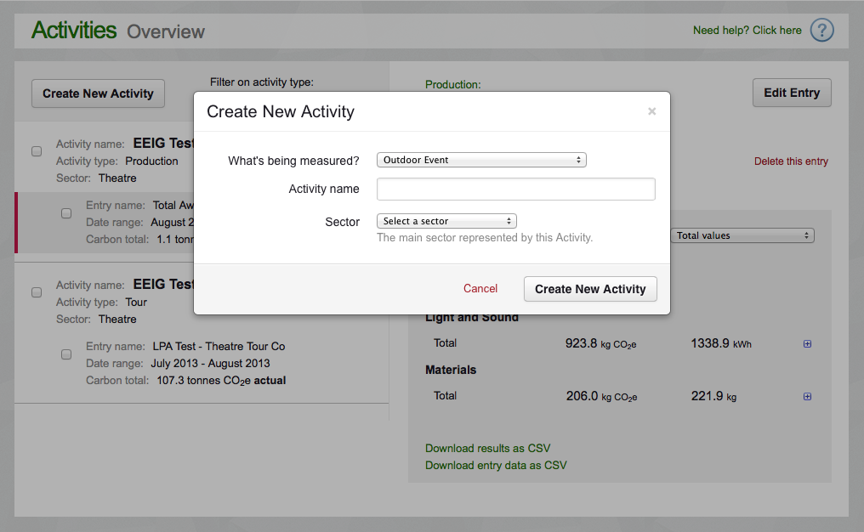

## General tab

Enter some general information on your Outdoor/Office/Venue or Cultural Building on the General tab.

*Example from Venue/Cultural Building Tool:*

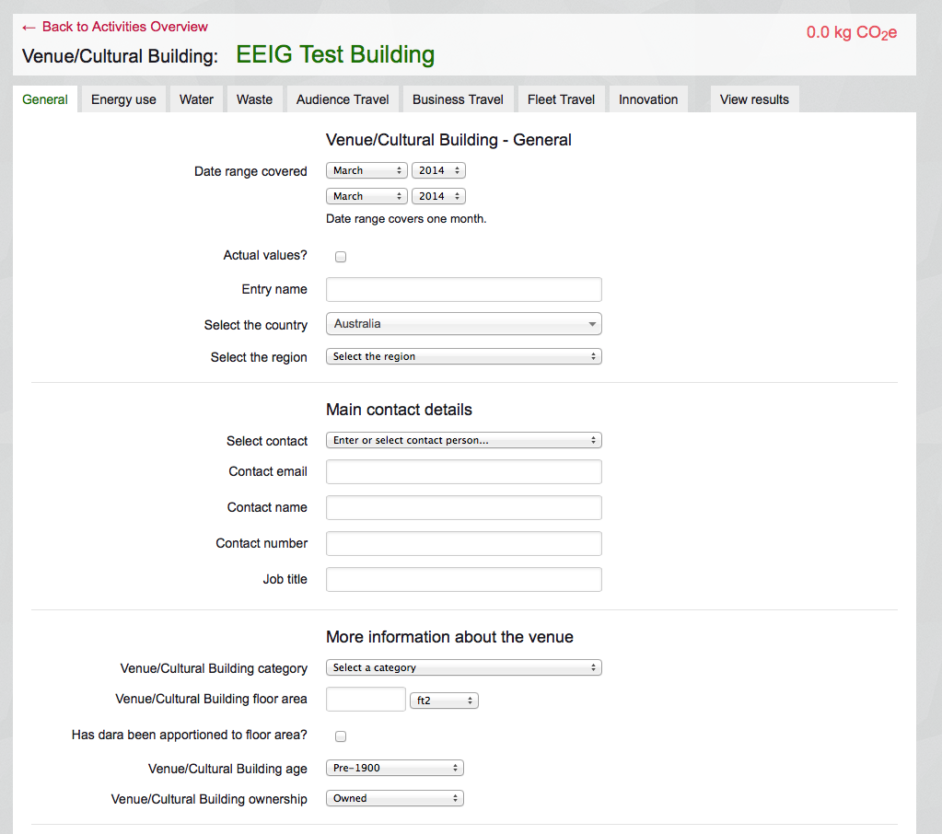

Scroll down.

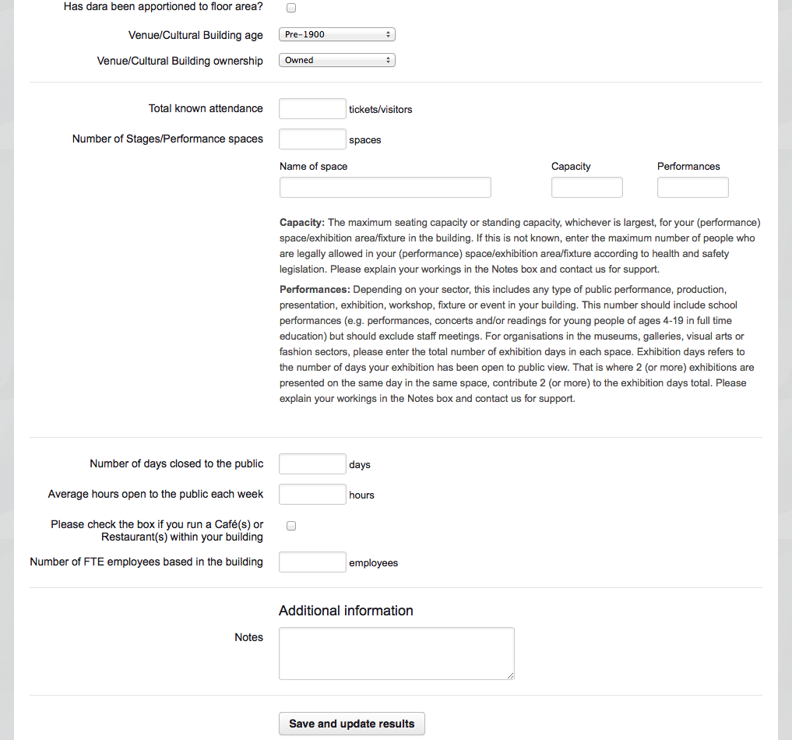

**CHECK**

* * = Required fields
* Help text will appear on the right hand side of the entry field when hovering or selecting an entry field.
* The selected entry field (i.e. where your cursor is) will be highlighted in light grey.
* Notes boxes are available on all tabs for any additional information you want to share with us.
* You can select members of your organisation who have already entered their details into the IG Tool through other entries to also be the designated contact person for your new entry from the scroll down menu without having to re-enter their details.

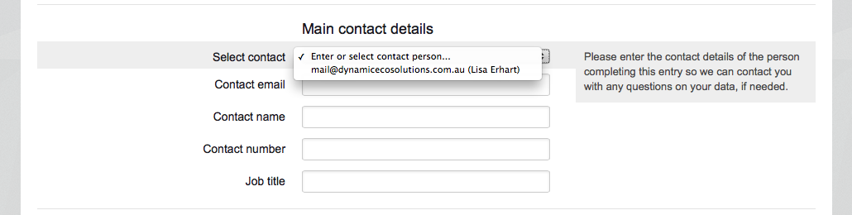

## Save and update button

Click on the Save and update results button at any point to update the results of your entry.



A yellow message will appear when you click on the Save and update results button indicating your entry has been saved and updated.

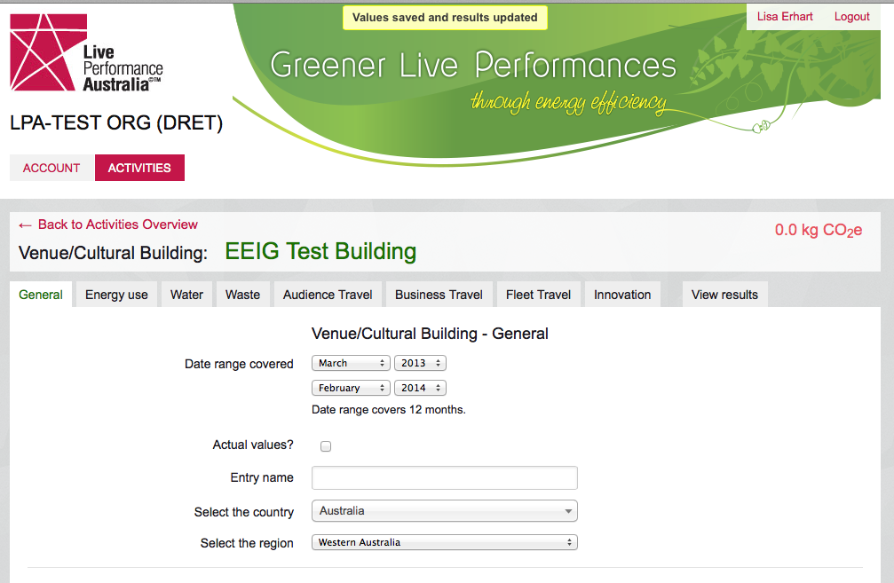

Your result figure will also be automatically updated and you can **view your final result at all times on the top right hand side corner of the screen in red** (0 tonnes CO2e).

## Complete the rest of the Tool

Go through the remaining tabs of the IG Tool completing the data boxes as appropriate.

**CHECK**

* The **Innovation** tab is for you to tell us about anything additional that you are doing, especially if it is new, to keep us informed of the latest developments in your sector.

## Results tab

Click on the **Results tab** for your carbon result and analysis.

*Example from Production Tool:*

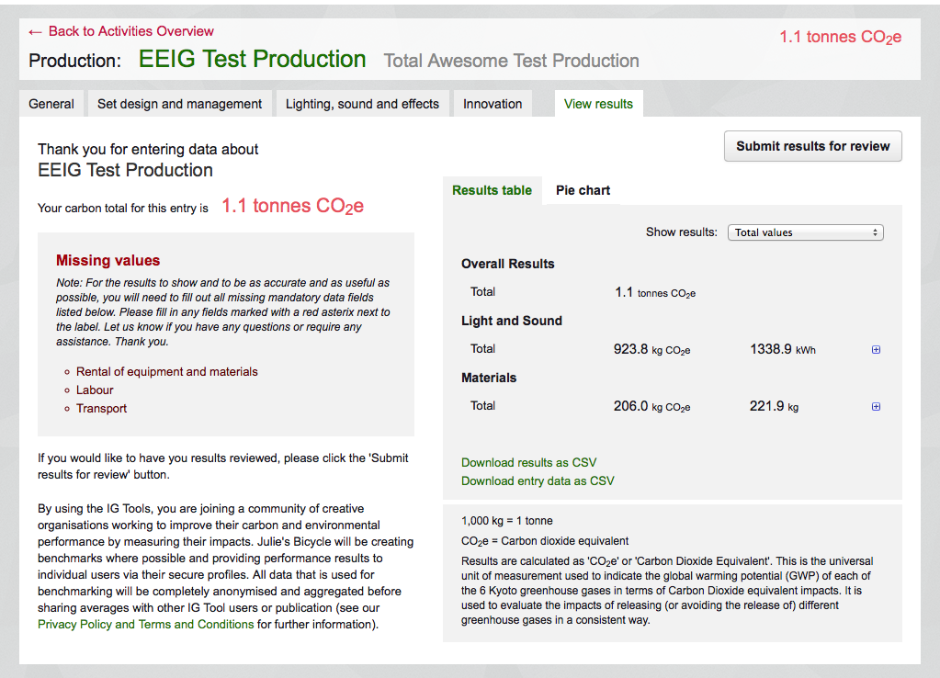

**CHECK**

* Clicking on **Save and update results** does not mean the entry is finalised – you can always go back and change your entry either by navigating through the tabs of the entry or via the Account tab.
* If you click on **Submit results for review** Live Performance Australia will be notified that the entry has been submitted and we will get back to you with feedback on your data within a week. However, you can at any point continue to edit your entry.

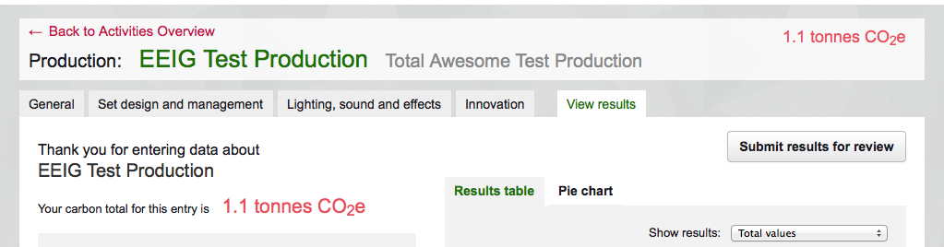

## Deleting IG Tool Activities or Entries

In the **Activities** tab you can opt to delete a particular Activity by selecting that Activity (it will be highlighted in light grey) and clicking on **‘Delete this activity’** link below the Add New Entry button.

*E.g. Delete August 2013 – September 2013 entry only from the EEIG Test Production activity*



You can also delete an entire activity, which may have numerous entries (e.g. a Production Activity with entries for 2010, 2011 and 2012). To do this go to the **Activities** tab, select the Activity in question (it will be highlighted in light grey) and then click on ‘Delete this activity’ link on the right hand side.

*e.g. Delete EEIG Test Production activity including all its entries.*

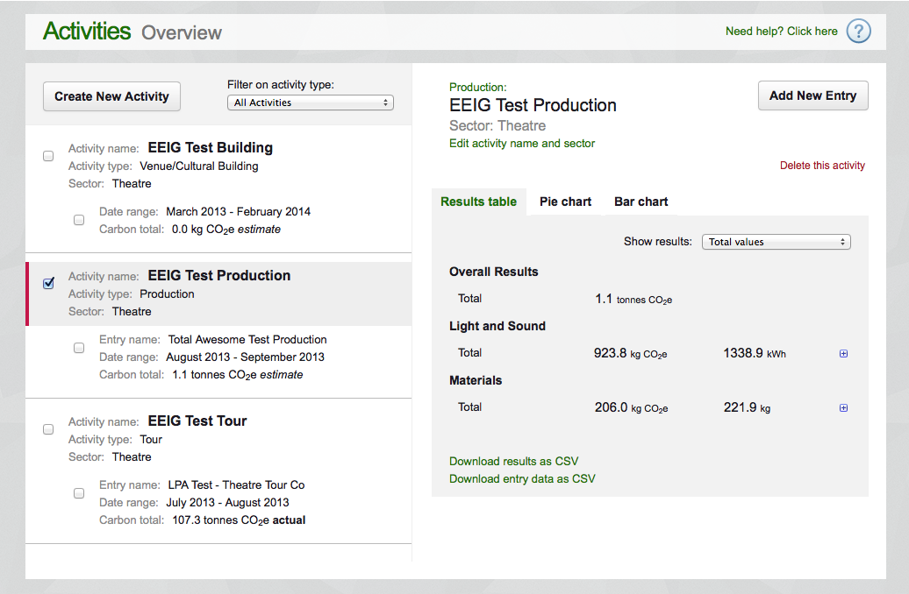

## Using the IG Tool as a database

The IG Tool also act as a database for your carbon footprints.

At any point during the process you can click on **Back to Activities Overview** on the upper left hand corner of the screen or the **Activities** tab. The Activities tab displays all entries you have ever submitted.

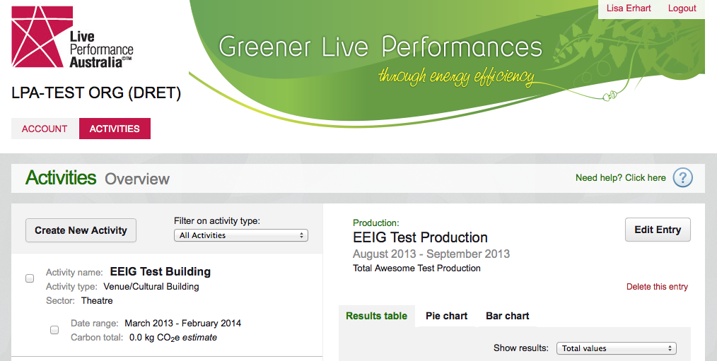

# Certifications and Awards

The IG Tool provides a comprehensive starting point for measuring your key environmental impacts. They are compatible with and complement other certifications and awards available, including ISO 14001, ISO 20121, BS 8901, Industry Green, A Greener Festival and Green ‘N’ Clean.

## For Buildings

**- IS0 14001:** An internationally recognised standard for implementing an environmental management system with guidance in your building. ISO 14001 provides assurance that the organisation is in control of the processes and activities that have an impact on the environment.

*http://www.iso.org*

- **Industry Green for Venues and Offices (IG)**: Industry Green is a simple voluntary certification programme that is based on four principles of environmental good practice: commitment, understanding, improvement and communication. With carbon dioxide (CO2) reduction at its heart, the certification covers impacts associated with energy, water, waste and travel alongside organisational commitment, improvement and communication. This certification is not currently available for Australian Venues.

http://www.juliesbicycle.com/industry-green

**- Green Building Council of Australia (Green Star)**: Green Star is a comprehensive, national, voluntary environmental rating system that evaluates the environmental design and construction of buildings and communities. Green Star has built on existing systems and tools in overseas markets including the British [BREEAM](http://www.breeam.org/) (Building Research Establishment Environmental Assessment Method) system and the North American [LEED](http://www.usgbc.org/leed/) (Leadership in Energy and Environmental Design) system. In addition, [VicUrban](http://www.vicurban.com.au/), in its work with the Melbourne Docklands' ESD Guide, provided the intellectual property to assist in the development of a local system.

<http://www.gbca.org.au/green-star/>

## For Festivals and Outdoor Events

**- BS 8901**: A British Standard specifying a sustainability management system for events. The guidance documentation promotes continual improvement of organisational sustainability performance by identifying what a company should consider/address.

*http://www.bsigroup.co.uk/en/Assessment-and-Certification-services/Management-systems/Standards- and-Schemes/BS-8901/*

**- ISO 20121:** An internationally recognised standard for event sustainability management systems built on BS 8901.

[*http://www.iso.org*](http://www.iso.org)

**- Industry Green for Festivals and Outdoor Events (IG):** Industry Green is a simple voluntary certification programme that is based on four principles of environmental good practice: commitment, understanding, improvement and communication. With carbon dioxide (CO2) reduction at its heart the certification covers impacts associated with energy, water, waste and travel alongside organisational commitment, improvement and communication. This certification is not currently available for Australian Festivals and Outdoor Events.

[*http://www.juliesbicycle.com/industry-green*](http://www.juliesbicycle.com/industry-green)

**- A Greener Festival:** A popular award for festivals in the UK and abroad. 46 festivals across the UK, Europe, Australia and North America have been awarded the prestigious Greener Festival Award for their green efforts in reducing their environmental impact 2011.

*http://www.agreenerfestival.com/*

**- Green ‘N’ Clean:** Originally launched by Yourope, the European Festival Association in 2006/07 as a printed booklet with environmental guidelines for music festivals, Green ‘N’ Clean is now supplemented by an online tool providing festival organisers with customised environmental advice plus an award for festivals who achieve a defined number of criteria in terms of environmental measures.

[*http://www.yourope.org/green_clean.aspx*](http://www.yourope.org/green_clean.aspx)

## Other Relevant Tools

The following Tools are particularly applicable to cultural activities though there are many other software Tool and resources to support environmental impact measurement.

**- sMeasure**: sMeasure is an online energy analysis tool specifically designed for small and medium businesses by researchers at the Environmental Change Institute at Oxford University. Using weekly meter readings for electricity and gas, sMeasure’s easy-to-use sophisticated weather analysis assesses the energy performance of buildings against weather conditions. In addition, the performance is assessed against national standard energy efficiency benchmarks thereby facilitating a good estimation of energy over- and under-spend.

[*http://smeasure.com/*](http://smeasure.com/)

**- Sustainable Event Management System (SEMS):** A comprehensive sustainability management system designed for all event and meetings organisers. Implementation of SEMS reduces the economic, social and environmental impact of an event and provides a reporting mechanism for attendees, staff, customers, shareholders.

*http://www.sustainableeventsolutions.com.au*

**- Eventberry:** Developed for event organizers, suppliers and venue managers, Eventberry is an events and buildings management system implementation for sustainability reporting, including information on risk analysis, environmental policy, energy, waste, water, community, construction, location, health and safety, purchasing and sourcing

*http://eventberry.com/*

**My Sustainability Manager:** A software tool newly-developed by Greener Museums to help UK-based museums measure, manage and report their carbon footprint on an ongoing basis. For a free trial click on:

*http://mysustainabilitymanager.com/free-trial/*

- The **Event Sustainability** tool is an online tool designed to support event managers and includes measurement check-lists, communication templates and industry best practice advice. The online tool generates a report, complete with a direct emissions calculation, which can be used as evidence of steps taken towards compliance with industry standards including BS 8901.

*http://www.eventsustainability.co.uk/pages/purchase.php*

# FAQs

## Which IG Tool should I use?

*For example*:

|  |  |
| --- | --- |
| **Office** | * Any office e.g. music theatre, performing arts, fashion, orchestra, visual arts, dance, etc. * Recording studios * Fashion Studios * Working from home |
| **Venue** | * Arena * Club * Theatre Venue * Stadium * Gallery * Museum * Indoor art fair e.g. Affordable Art Fair * Indoor fashion show |
| **Tour** | * Any tour e.g. orchestra, theatre, dance, fair, band, artist, etc. |
| **Festival** | * Any festival e.g. music, theatre, performing arts, visual arts etc * Outdoor art fair e.g. Frieze Art Fair * Outdoor fashion show * Site-specific work |
| **Production** | * Any production e.g. theatre, festival, music, performing arts, visual arts, etc |

## Should I group activities per Season?

* Choose the most logical management process for your needs but one suggestion is to ‘Create a New Activity’ for your season ‘2014 Season’ then establish a new entry for each Production or Tour underneath that.

## Can multiple users access the one Account?

* Yes. Multiple users can access the one account. Once the account has been set-up, the Administrator can allocate multiple users to have access to different aspects of the tool and the information collected. Users can be allocated to any one or multiple ‘Activities’ already established within the tool.

## I can’t access the LPA IG Tool

* You need to have registered or signed into the LPA IG Tool website to be able to access the LPA IG Tool. If you have not yet registered please do so at:

*www.lpa.ig-Tool/signup*

## Can I reset my password?

* To **reset** your password click on **Forgotten your password?** on the right hand side of the screen.

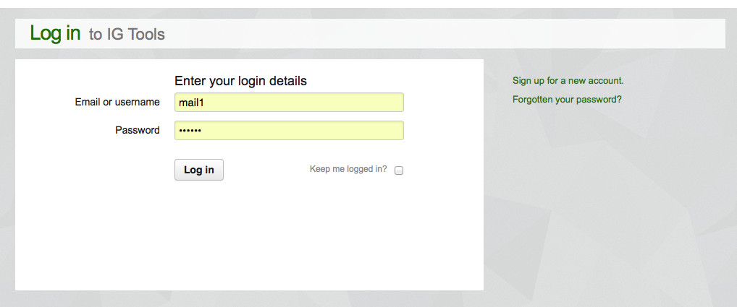

* Enter your email address and click on **Send my reset code.**

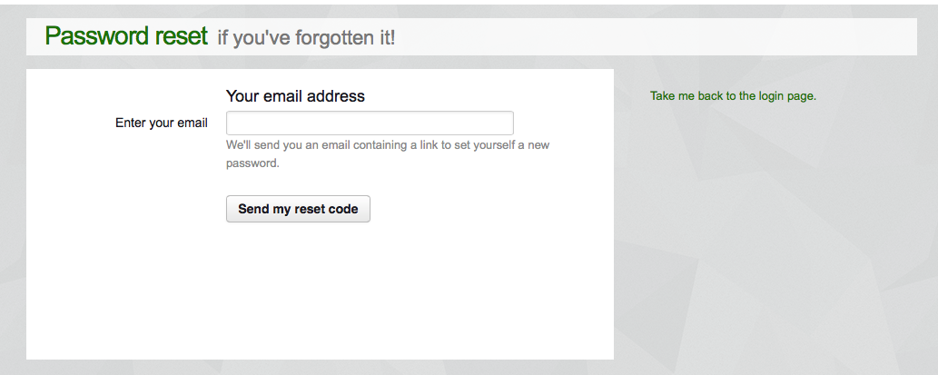

* You will be emailed a link to the LPA IG Tool – click on the link to reset your password.

## What do I do if my building has been completely or partially shut for part of the reporting timeline?

* If the whole or part of your building has been shut during the reporting timeline (for example for refurbishment) then please report your energy and water usage for the entire year regardless of whether you have been open to the public.
* Ensure that this closure is reflected in your level of activity (e.g. number of tickets sold/number of performances/visitors).
* Please make a note in the notes box on the IG Tool to tell us what you’ve done.

## My building has been completely or partially shut for part of the season?

* If you are already monitoring your energy and/or water usage via smart meters or other energy and water management software (such as sMeasure), please export all data corresponding to the timeline you enter onto the IG Tool, sum your data and enter those annual totals into the IG Tool.
* Please contact us if you have any questions or concerns about how to go about this.

## How do I calculate my full-time equivalent employees?

* Assume an average shift of 8 hours, and include volunteers and interns providing they use the building on a full-time basis. Include both day and night shifts as the energy and water usage relating to these shifts will be reflected in your invoices.

## How do I use the Tool if I am in shared office space?

* Liaise with your landlord to determine your office space’s consumption or cost for energy, water and waste.
* If your individual usage cannot be isolated then ask your landlord for the energy and water consumption for the entire office, the total square metres/feet of the whole building and the total square metres/feet of the space you occupy.
* You can then work out the percentage of total building space you occupy and use that percentage to estimate just your own usage from the total, and enter those figures into the IG Tool. Contact Julie’s Bicycle and we can help you with your estimates if needed.

## How do I use the IG Tool if I am based in a University or local council?

* Similar to the answer above, treat the University or local council as the landlord and see if they can provide the information required.

## How can I measure a city-based festival (e.g. the Adelaide Fringe)?

* **Divide venues/cultural buildings** used into indoor and outdoor and use the Venue/Cultural Building Tool and the Outdoor Events Tool accordingly to enter data.
* For example a city-based literature festival could use the Office IG Tool for their annual office results, the Outdoor Events IG Tool for an outdoor event they hold, the Venue/Cultural Building IG Tool for an indoor launch event and the Touring IG Tool to cover authors traveling to the city.

## How do I proceed if I am a complex organisation with multiple spaces and events?

* Divide your spaces into indoor and outdoor and use the venue/cultural building and/or office Tool for all indoor spaces, and the Outdoor events Tool for all outdoor spaces to enter data.

## How can I measure an office-based organisation, which organises outdoor and indoor events including site specific work elsewhere?

## **AN EXAMPLE Case Study – Mixed use Organisation: JB Productions**

JB Theatre is a 1000m2 building - office space and a theatre. JB Productions own the JB Theatre where they put on productions and operate their office. In addition a small design company, Delicate Design, occupies 200m2 of the JB Theatre. JB Productions run an annual festival - ‘JulieFest’- place in: 2 separate indoor venues (JB Theatre and the Popcycle Cinema) and 3 outdoor venue spaces.

Here’s the framework to capture information and calculate your GHG impact:

1. Office space: add JB Theatre under the venue category and put all the energy and water data in for the building so that it includes both theatre space and office space. Chopper Design is responsible for its own emissions. Chopper Design occupy 20% of the entire space ([200/1000]*100%]. So we will enter 80% of the total units for energy and water. That’s JB Theatre covered.
2. Energy bills for JB Theatre will already cover the period affected by Julie Fest. The other venue for Julie Fest, the Popcycle Cinema, is used all year round and operated independently- JB Productions has no influence over their energy and therefore the responsibly lies with them.
3. The three outdoor venues can be entered as separate Activities in the IG Tool for festivals. The relevant data can then be entered into the tool for each area.
4. For each Activity JB Productions could include waste data.
5. For each production at the JB Theatre, JB Productions could use the productions tool on IG Tool to specify the materials used in the production and how they were disposed of afterwards.
6. JB Productions could include everyday business travel data. This could also cover any transport or freight involved in setting up the festival venues, and travel and transporting materials to Popcycle Cinema (just add this in the JB Theatre business travel section).
7. Audience travel could also be included. There are two choices – JB productions could survey their audiences to gain an understanding of the transport modes used and distances travelled. Or they could check the box in the IG Tool to allow default information (developed – at this stage - by Julie’s Bicycle and dependent on festival and venue size) to be used instead.

* Use the Office IG Tool to enter your office data, the Outdoor Events IG Tool for your outdoor events including sit specific work, and the Venue/Cultural Buildings IG Tool for all indoor work.

## Do the IG Tool allow me to offset my emissions?

* There is currently no option on the IG Tool for you to offset your emissions. LPA recommends offsetting as your last resort after all reasonable action has been taken to reduce your direct (e.g. energy and water) and indirect (e.g. audience and artist travel) emissions as much as possible.
* If you are considering offsetting part or all of your emissions make sure you opt for offsetting companies with at least Gold Standard accreditation.

## Calculating the impact of accommodation on tour.

* When determining the impact of domestic (home-stay) accommodation choices whilst on tour; calculate the number of accommodation nights, as directed in the tool, then multiple the total by 0.75. Domestic accommodation is known to be less impactful than hotel rooms hence the reduction

## . Compare the reduced impact of a sub-tour.

* Touring coordinators recognise the significant GHGs caused by long-haul (international) flights and are therefore become more active in planning smaller, sub-tours that take place during the larger tour.  
    
  To demonstrate the positive outcomes achieved – Create your Tour Activity the log separate ‘Entries’ for each related tour – Entry 1 will by the primary tour and include the long-haul flights. Entry 2 will be the secondary tour and only include domestic flights/travel, as required.   
    
  After completing the data entry, generate respective reports for each entry and then compare the ‘Per Show’ GHG impact. This will provide sufficient justification for the additional effort dedicated to the planning for the secondary tour.

## If I still have questions about how to use the IG Tool what do I do?

* The LPA Greener Live Performance team is also available via email [greener@liveperformance.com.au](mailto:greener@liveperformance.com.au) or phone (03) 9614 1111 at any time for support and troubleshooting.

## How do I track success?

* If you would like to track your success on a minute by minute basis or hour by hour basis you may consider installing smart meters or half-hourly meters which will enable you to track your progress closely. Larger organisations may already have such infrastructure in place and use such sophisticated software, so make sure to enquire within your organisation for further details.
* If you would like to track your success on a week by week basis, you may consider using energy management software to use where you input your meter readings on a weekly basis and you are able to track progress through visual aids (e.g. graphs).
* If you would like to track your success on a monthly basis, you can create monthly entries on the IG Tool and enter energy and water data as you go and compare the carbon footprint from one month to the next.
* If you would like to track progress on yearly basis you can create yearly entries on the IG Tool and enter energy and water data once the year has ended (i.e. March 2013) and compare the carbon footprint of one year to the next. You are welcome to add data for previous years (2012-13) for your own comparison.

## Where can I find more information on payback options for different capital investments I am considering?

* Julie’s Bicycle is currently developing generic payback guidelines to use.
* Payback periods can often be complicated by a range of factors and are best assessed on a case-by-case basis once you have projected your energy costs against the capital investment. Suppliers of low carbon solutions will often be happy to forecast payback periods for you. It worth noting that energy prices are predicted to rise well beyond inflation and therefore payback periods may become more favourable if this is taken into account too.
* Below are some indicative payback periods:
* **Timer Switches** – Timer switches can offer excellent payback periods, often under 1 year. Fitted to printer/photocopiers, water coolers, vending machines, bar fridges or TVs they can have an instant impact.
* **LED lighting** –LEDs can use around 80%+ less energy than incandescent equivalents. LED lighting is reducing in cost but investing in lights which offer comparable lighting quality to non-LED lights can be costly. It should be noted that, providing you source a good product, their reliability and life span means there is very little maintenance cost.
* **Voltage Optimisation** – Voltage optimization can offer favourable paybacks and the relevant suppliers will often be helpful in providing you with the predicted payback periods. Voltage optimisation payback is usually around 5 years.
* **Solar Panels (Photovoltaics)** – Since the Feed In Tariff (FIT) rate has been reduced Solar Panels have increased their payback periods. Payback periods now start at around 10 years upwards. However the costs of solar panels and their installation is becoming more competitive. It may also be worth investigating Photovoltaic-Thermal (PVT) solutions. PVT panels offer higher efficiency electrical production at higher temperatures, and heat water too, which may qualify them for more favourable government tariff rates.
* **Combined Heat and Power (CHP)** – Worth investigating for large buildings that have a relatively high and consistent heating demand. They can offer payback periods starting from around 5 years.
* There are many other suppliers who offer retrofit products such as boiler optimization or air conditioning energy savers. These can offer favourable payback periods of 2 or 3 years depending on your current model.
* Often completely replacing an old piece of equipment such as fridges, TVs, computers, boilers and general white goods can offer excellent payback periods if replaced with energy efficient modern equivalents.
* Introducing ceiling and cavity wall insulation can be done at very low cost with government incentives or grants and can therefore give excellent payback periods.

## What Grants or Financial incentives might I be entitled to in order to fund low-carbon solutions?

* **Clean Energy Finance Corporation -** The CEFC offers loans through various banking institutions or on-bill financing schemes through energy retailers; such as Origin Energy. Applying to the CEFC you can receive a loan against an investment you make in technologies that will help you reduce your overall energy costs. Once you have a quote from a specific supplier and provided energy data for your premises (i.e. energy data that you input into the IG Tool) this is submitted to the CEFC. They will then produce a report, which indicates predicted payback periods. This allows you to assess the financial savings from energy reduction against the monthly loan repayments for the capital cost. They cover many solutions including LEDs, Solar panels, Biomass boilers and Voltage Optimization.

*https://www.cleanenergyfinancecorp.com.au*

* Enquire through your Local Government Authority, for relevant schemes and grants to help you implement energy saving technologies.

## Having trouble reading my invoices to complete the IG Tool – what do I do?

* Contact your energy or water supplier. They will be able to help.
* In short you do not need to worry about most information on the invoices but you only need to be looking for the following:
* For your mains energy invoices (i.e. electricity, gas):

1. Date range (must add up to a period of 12 months or for the duration of the outdoor event);
2. Metre numbers (if applicable - might need to add up more than one metre for that space/event);
3. kWh figure(s).

*Example A: Electricity Invoice*

* Date range: Red circle
* Meter number: Green circle
* kWh figures: Blue circle



*Example B: Gas Invoice*

* Date range: Red circle
* MJs figure: Blue circle

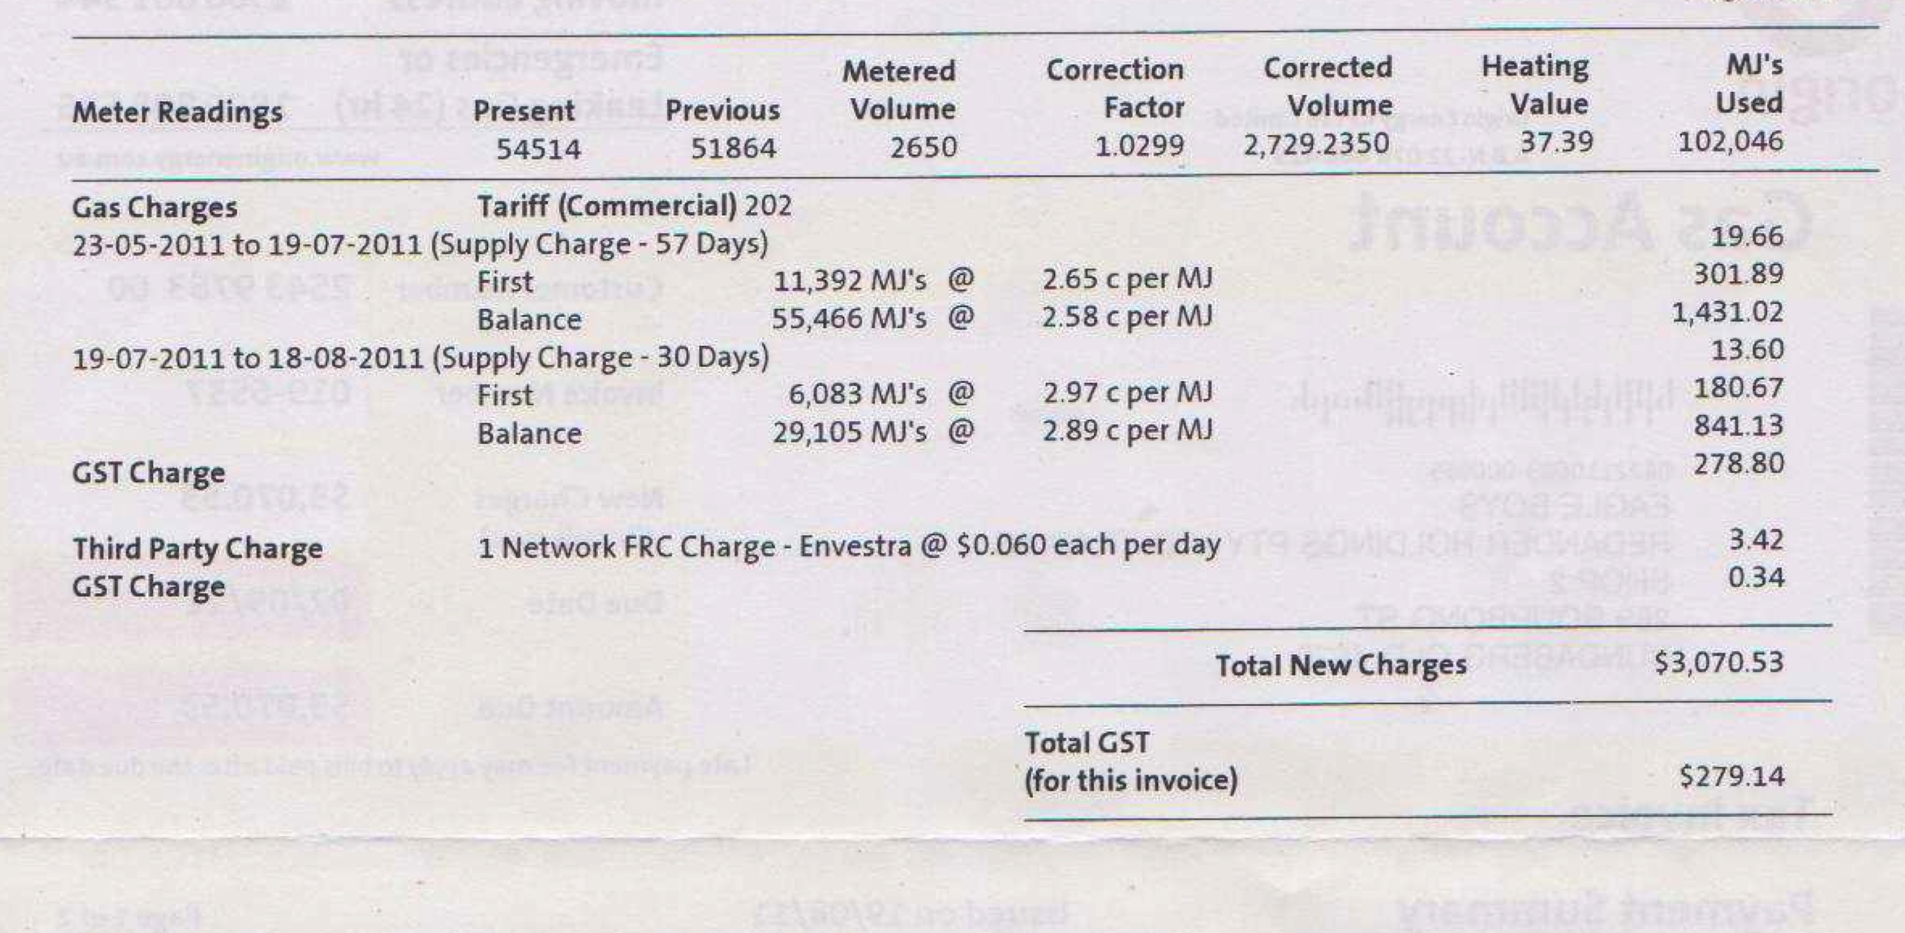

* For your other energy invoices (i.e. diesel, biodiesel, heating oil, bottled gas):

1. Date range (must add up to a period of 12 months or for the duration of the outdoor event);
2. Litres figure(s).

* For your water and/or sewage invoices:

1. What the invoice covers (i.e. water and/or sewage)
2. Date range (must add up to a period of 12 months or for the duration of the outdoor event);
3. Metre numbers (if applicable - might need to add up more than one metre for that space/event);
4. Cubic metres (m3) figure(s).

# Methodology and Definitions

## How do the IG Tool calculate greenhouse gas emissions from your data?

The Tool primarily uses the Australian Department of Climate Change and Energy Efficiency (DCCEE), the UK Department of Energy and Climate Change (DECC) and UK Department for Environment, Food and Rural Affairs' (DEFRA). The most recent greenhouse gas (GHG) emission conversion factors for company reporting are 2013.

## How is the IG Tool data used?

All individual IG Tool data entries are treated confidentially and will not be shared with any other party unless permission is directly sought and given. The data is aggregated, which enables us to develop a global database for the sector, giving us unique insight into creative activities and helping to generate world-first benchmarks.

Examples are: the per seat emissions benchmark for a theatre; the per ticket benchmark for a Australian arena tour; or the per audience day for a large music festival.

For the development of robust benchmarks we require as much data as possible: by using the LPA IG Tool you support our benchmarking project.

For more information on data protection please see our  **PRIVACY POLICY:**

## Definitions

***Emissions*** *refer to the release of a substance (usually a gas in the case of climate change) into the atmosphere.*

***The 6 Greenhouse gases*** *identified in the Kyoto Protocol are carbon dioxide (CO2), methane (CH4), nitrous oxide (N2O), hydrofluorocarbons (HFCs), perfluorocarbons (PFCs) and sulphur hexafluoride (SF6).*

*These emissions are reported as* ***carbon dioxide equivalent (CO2-e),*** *the universally adopted measurement which indicates the warming potential of each of the 6 main greenhouse gases – which, upon release, trap heat in the earth’s atmosphere, thereby altering the global climate. Carbon dioxide equivalent is used to evaluate the impacts of releasing (or avoiding the release of) different greenhouse gases.*

***Global warming*** *is the additional heat/energy, which is retained in the Earth’s ecosystem through the release of this gas in the atmosphere. The additional heat/energy impact of all other greenhouse gases is compared with the impacts of carbon dioxide (CO2) and referred to in terms of carbon dioxide equivalent (CO2-e).*

***National Greenhouse Accounts (NGA)*** *such as those published by the Department of Climate Change and Energy Efficiency are designed for use by companies and individuals to estimate greenhouse gas emissions. Factors are estimated by the Department using the Australian Greenhouse Emissions Information System (AGEIS) which is used to collect emissions information from companies reporting under the Energy Efficiency Opportunities Act of 2008. The NGA are usually revised on an annual basis.*

*In preparing the LPA IG Tool conversion factors, a mix of both Australian and UK factors where utilised to ensure all components of IG had an associated GHG Factor attributed.*

*Download a pdf of the conversion factors we use:*

***Australian conversion factors***

[*http://lpa.ig-tools.com/files/LPA_IG_Tool_SourceFactors.pdf*](http://lpa.ig-tools.com/files/LPA_IG_Tool_SourceFactors.pdf)

***UK conversion factors***

[*http://www.juliesbicycle.com/media/igtooldocs/International_Conversion_Factors.pdf*](http://www.juliesbicycle.com/media/igtooldocs/International_Conversion_Factors.pdf)

*Note: In the case of audience travel for festivals and venues, if no raw data is available we use default data based on Julie’s Bicycle research, specifically Jam Packed Part 1, published in 2009, which looked at audience travel emissions to festivals.*